**Case Studies**

**TruCryo**

**Introduction to Cryostimulation – Kaasen, Kaasen life and Kaasen equine.**

Cryostimulation is a technique for a drug-free, non-invasive treatment of pain, inflammation and muscular-skeletal trauma. Its indications are for both acute and chronic conditions.

KAASEN and CRYOSEN delivers -78°C degrees and 50 bar pressure using liquid C02.

The C02 is filtered and pushed out through a funnel in the form of a cold vapour forming a dry ice layer on the skin surface area.

When the sub-zero temperature covers the skin, the sudden drop in heat stimulates the temperature receptors, prompting the brain to transmit messages throughout the body.

The Capillaries (blood vessels) then undergo severe vasoconstriction to protect the essentials organs and the core temperature from dropping.

Vasodilation occurs releasing important amount of blood to the effective area reducing pain and balancing out inflammation as well as reducing any swelling.

TruCryo have created case studies carried out by professional and qualified practitioner in specific fields: -

**David Jenkins – Professional Sports Therapist – Scotland**

David created a team of highly qualified professionals with extensive experience to offer 'The Full Package' in personal health and wellbeing. In 2012 David was successful in becoming the first Graduate Sports Therapist in Scotland to work within the NHS. This was at the Queen Elizabeth National Spinal Injury Unit, based at the Southern General Hospital Glasgow.

David Jenkins has 20 plus years’ experience in professional sport, - Scottish Premier League, Elite Professional Ice Hockey, Professional Mixed Martial Arts and recently The World Karate Championships at Ingliston Edinburgh 2011.

BSc Hons SPORTS THERAPY (2:1)– University of Teesside 2009

Examiner / Assessor – For Society of Sports Therapists- 2007 - present

Moderator – Degree Programme BSc Hons Sports Therapy – Various Universities – 2007 -

Manual Therapy and Mobilisations for the Lower Limb –Education & Rehab Services 2006

Manual Therapy and Mobilisations for the Upper Limb – Education &Rehab Services 2006

**Patricia Hegharty - Massage Therapist, Level 5 Advanced Sports therapist- Belfast N. Ireland**

Specialising is mallusk sports massage, dry needling and cryotherapy. In the industry for 10 years

**Hugh Carney - qualified Neuromuscular Therapist and Orthopaedic Sports Massage Therapist.**

**Northern Ireland**

Hugh has a wealth of sporting knowledge and now as a qualified therapist his view to firstly help people avoid injury and recover faster between training and sporting events, but also to help people with a wide range of injuries, from acute to long lasting chronic Pain. Catering for individuals of all ages, whether from occupational, normal daily living or sporting activities.

**Agnieszka Hawrysz - Sports Injury Clinic Physiotherapist – Dublin**

15 years as a physiotherapist and a member of Irish Association of Physical Therapy (IAPT)

In 1991 the Irish Association of Physical Therapists (IAPT) was established as the Professional Body ensuring excellence in the field of musculoskeletal health. The IAPT represents its members who practice Physical Therapy throughout Ireland. Physical Therapy as practiced by its members has developed over the past 13 years as a separate and distinct form of assessment, treatment and management of musculoskeletal disorders.

**Jenny Borley – Cardiac Nurse – Qualified NHS UK NURSE**

She is the lead for the Heart Failure team who is identifying and consenting patients within cardiology, colorectal, urology and breast care.

**Case Study - Pain Management**

|  |
| --- |
| **General pain management**  **Users** - Dave Jenkins –Hugh Carney - Agnieszka Hawrysz - Jenny Borley  OBJECTIVE. To evaluate the effect of Kaasen cryotherapy on people’s pain.  METHOD. An open prospective study was conducted in patients, with several types of pain. At entry, the patients recorded a pain score, marked on a number system 10 being the worst and 0 the least. There was also a mobility score on the range of movement before and after treatment. This measure was repeated for comparison at the end of the treatment session.  RESULTS. Between May 2017 and June 2017, 26 patients were treated for pain. The area of pain was caused by various conditions such as sprained ankles, muscle injury, arthritis inflammation in the joints, sciatica and degenerative conditions. All of the patients had significant improvement in pain relief and expressed further treatments for long term relief.  CONCLUSION. Kaasen cryotherapy is a modern non-pharmacological/invasive technique to treat pain in many people and was evident that CryoStimulation is very effective application for it |

**The case study process for pain**

The process of using Kaasen for pain was a simple and straight forward procedure.

The patient was brought in to sign a disclaimer and asked where the pain was.

A visual observation was carried out and accessed but not diagnosed. The patient was then positioned comfortably, and the skin area was exposed to treat the area of pain.

The area was cleaned and dry removing at creams or lotions as well as makeup if present.

A note was taken on the severity of the pain from the pain scale 10 to 1. 10 being the worst.

A flexible exercise was taken too to determine the restricted movement, and this was also noted and observed.

Kaasen was then applied for a minimum of 30 to 60 seconds treatments to achieve thermic shock around the area and was indicated when the light from the Kaasen is turned blue.

A wait for 5 minutes was observed for the body homeostasis to regain its normal temperature after the Kaasen treatment

The patient was asked if they feel any discomfort and all of them responded No to this question.

Physio or a massage was applied after the treatment to gain movement and flexibility. This was carried out according to the patient movements. No other medication or modality equipment was used after Kaasen was used.

**Analysis**

After the treatment and Physio or massage it was evident that in all of the patients that was treatment by Kaasen there was a significant decrease in pain and increased mobility

**Case study - Swelling and Inflammation reduction**

|  |
| --- |
| **Swelling reduction**  **Users** - –Hugh Carney - Agnieszka Hawrysz - Jenny Borley  OBJECTIVE. To evaluate the effect of Kaasen cryotherapy on swelling and inflammation.  METHOD. A study was conducted on patients, with several types of swelling especially on the ankle and knee joints  RESULTS. Between January 2018 and February 2018, 5 patients were treated for swelling and inflammation reduction. The area of swelling was caused by various conditions such as sprained ankles, or inflamed joints due to excessive use and various underlining conditions that causes swelling and inflammation. All of the patients had significant improvement in reduction of swelling and expressed further treatments for long term relief.  CONCLUSION. Kaasen cryotherapy is a modern non-pharmacological/invasive technique to treat swelling and inflammation in many people and was evident that CryoStimulation is very effective application for it |

**The case study process for Swelling and Inflammation reduction**

The process of using Kaasen for pain was a simple and straight forward procedure.

The patient was brought in to sign a disclaimer and asked where the pain was.

A visual observation was carried out and accessed but not diagnosed. The patient was then positioned comfortably, and the skin area was exposed to treat the area of pain.

The area was cleaned and dry removing at creams or lotions as well as makeup if present.

Kaasen was then applied for a minimum of 30 to 60 seconds treatments to achieve thermic shock around the area and was indicated when the light from the Kaasen is turned blue.

A wait for 5 minutes was observed for the body homeostasis to regain its normal temperature after the Kaasen treatment

The patient was asked if they feel any discomfort and all of them responded no to this question.

Only physio was applied after for flexibility.

Before After

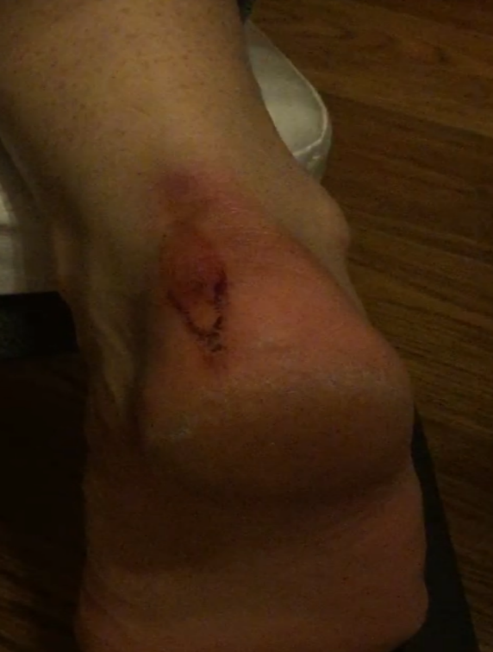 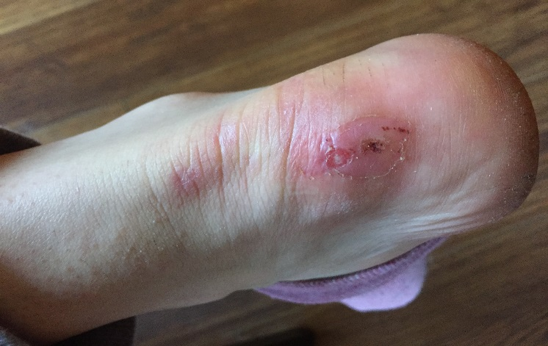

The above picture show swelling and inflammation in the before picture. After 2 30 seconds Kaasen treatment and after 30 minutes its evident that reduction in the swelling and inflammation

**Analysis**

After the treatment it was evident that in all the patients that was treated by Kaasen there was a significant decrease in swelling and inflammation

**Case study - Post-operative treatment to increase mobility**

|  |
| --- |
| **Post-operative treatment to increase mobility**  **Users** – Dave Jenkins  OBJECTIVE. To evaluate the effect of Kaasen cryotherapy on post-operative treatment to increase mobility.  METHOD. A study was conducted one patient, that just under gone a knee operation and had restricted movement after it.  RESULTS. A patient was treated after a knee operation to help with swelling and to increase mobility so they can get back in playing sports. The stiches after the operation is around 4 inches on the outside of his right leg. The patient had the operation 5 days before the first Kaasen treatment. The aim was to increase the mobility. The patients had significant improvement in mobility with reflexology techniques and expressed further treatments for long term relief.  CONCLUSION. Kaasen cryotherapy is a modern non-pharmacological/invasive technique to treat post-operative in people and was evident that CryoStimulation is very effective application for it |

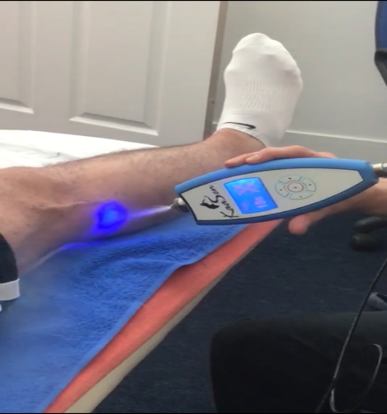

**Analysis**

After the treatment it is evident that patients with post-operative surgery using CryoStimulation treatment by Kaasen there was a significant increase in the healing process and mobility

**Case study - Psoriasis**

Psoriasis is a skin condition that causes red, flaky, crusty patches of skin covered with silvery scales. These patches normally appear on your elbows, knees, scalp and lower back, but can appear anywhere on your body. Most people are only affected with small patches. In some cases, the patches can be itchy or sore.

|  |
| --- |
| **Treatment for Psoriasis**  **Users** – Hugh Carney  OBJECTIVE. To evaluate the effect of Kaasen cryotherapy on the reduction of Psoriasis  METHOD. A study was conducted 6 patients using Kaasen treatment.  RESULTS. 6 patients was treated for psoriasis and the observation was that all of the patients had reduction of the psoriasis  CONCLUSION. Kaasen cryotherapy is a modern non-pharmacological/invasive technique to treat psoriasis and was evident that CryoStimulation is very effective application for it |

Kaasen was then applied for a minimum of 30 to 60 seconds treatments to achieve thermic shock around the area and was indicated when the light from the Kaasen is turned blue.

A wait for 5 minutes was observed for the body homeostasis to regain its normal temperature after the Kaasen treatment

The patient was asked if they feel any discomfort and all of them responded No to this question.

No other medication or modality equipment was used after Kaasen treatment

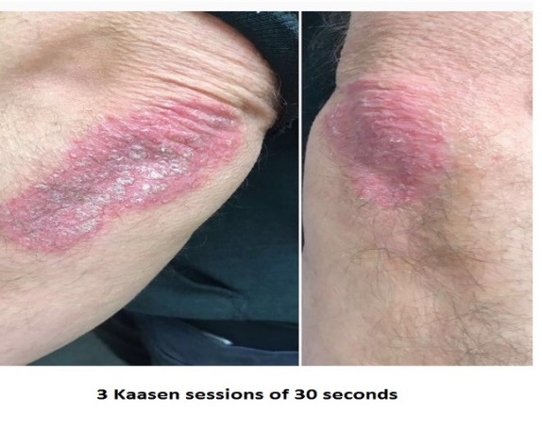

**Analysis**

After the treatment it is evident that patients with psoriasis using CryoStimulation treatment by Kaasen there was a significant decrease in the healing process and shrinking the effect area. A minimum of 3 Kaasen treatments will be enough to see the reduction of the psoriasis

**Case study - Body Sculpting**

|  |
| --- |
| **Treatment for Body Sculpting**  **Users** –  **Patricia Hegharty - Massage Therapist**  OBJECTIVE. To evaluate the effect of CryoSen cryotherapy on fat cells in the body  METHOD. A study was conducted on 4 patients.to CryoStimulation fat cell on different parts of the body adjunctively with a lymphatic massage.  RESULTS. All 4 patients noticed a reduction of mass around the area being treated to CryoStimulation  CONCLUSION. Kaasen cryotherapy is a modern non-pharmacological/invasive technique to aid and manage weight loss as an adjunctive measure. This is no way in any means as a permanent weight loss therapy without further investigation. |

CryoSen was applied for a minimum of 60 to 120 seconds treatments to achieve thermic shock around the area and was indicated when the light from the Kaasen is turned blue.

A wait for 5 minutes was observed for the body homeostasis to regain its normal temperature after the CryoSen treatment

The patient was asked if they feel any discomfort and all of them responded No to this question.

A lymphatic massage was carried out to encourage the lymph nodes to drain out any water retention which initially has caused the dramatic reduction after the first full session. Over time it is known that fat cell within a human body do diminish with cold and do break down and gets flush out through our digestive system. A course of 5 to 10 treatments is required to achieve long term effects.

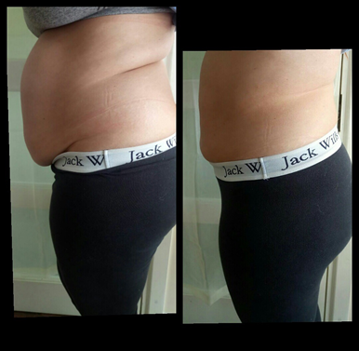 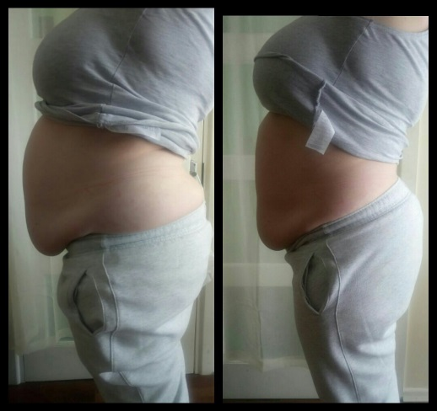

**Analysis**

After the CryoStimulation and Lymphatic massage it is evident that patients will see a noticeable difference the area treatment is terms of reduction of fat. A number of between 5 to 10 treatments is required to get further benefits. More investigation is required to determine the lasting effect.

**Case study - Cryo Facial**

Studies show that cryotherapy [stimulates the collagen](https://www.researchgate.net/publication/51064578_Thermography_study_of_skin_response_due_to_whole-body_cryotherapy), so doing facials is a more targeted way to get that benefit, rather than ice packs

|  |
| --- |
| **Treatment for Cryo facial**  **Users** –  **Patricia Hegharty and Jane Borley**  OBJECTIVE. To evaluate the effect of CryoSen cryotherapy on face and neck  METHOD. A study was conducted on 15 patients.to CryoStimulate facial receptors to increase the collagen by using CryoSen uniquely designed facial nozzles for 1 minutes followed by a cool lymphatic massage.  RESULTS. All 25 patients noticed instant tightening and a glow in the face. The cool lymphatic massage after the CryoStimulation reduces any puffiness around the face. All the patients felt rejuvenated.  CONCLUSION. Kaasen cryotherapy is a modern non-pharmacological/invasive technique for anti-wrinkle and increase collagen for the face. It adds vasodilation and increases blood flow to re-oxygenate new nutriments to the face. More investigation is required to |

Kaasen Life was applied for a minimum of 60 seconds treatments to achieve thermic shock all over the face.

A wait for 5 minutes was observed for the face homeostasis to regain its normal temperature after the Kaasen treatment

The patient was asked if they feel any discomfort and all of them responded No to this question.

A lymphatic massage was carried out to encourage the lymph nodes to reduce any puffiness after the first full session. Over time it is known that increase collagen is increased leaving the face feeling tighter and glowing. A course of 5 to 10 treatments is required to achieve long term effects.

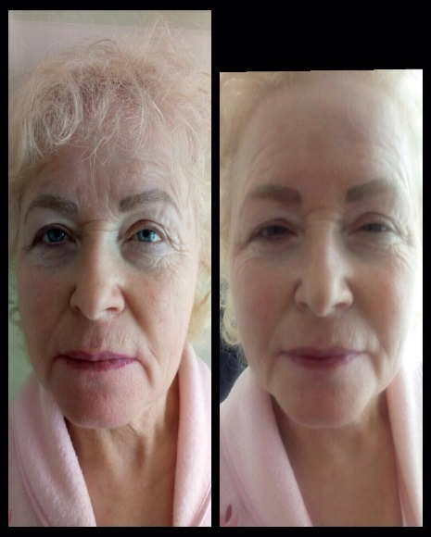  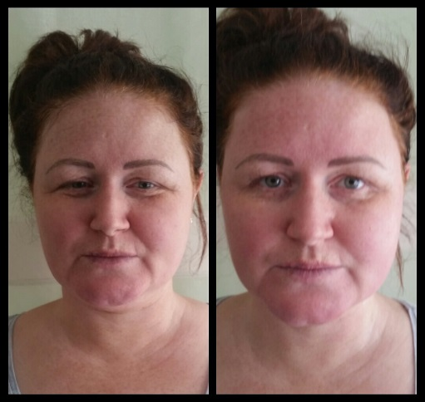

**Analysis**

After the CryoStimulation of the face and cool Lymphatic massage it is evident that patients will see a noticeable difference the area treatment is terms of reduced and finer wrinkles. A softer complexion is observed from one session. The cool massage is very noticeable around the eyes. A number of between 5 to 10 treatments is required to get further benefits. More investigation is required to determine the lasting effect.